Lab Exercise: Singly Linked Lists in C and C++
Solve the below problems in C/C++ and give the time and space complexities

5. Write a C and C++ program for implementation of Singly Linked List consisting of following operations:
• Inserting a new node in a Linked List at the beginning
• Inserting a new node in a Linked List at the end.
• Deleting a node from a Linked List from beginning
• Deleting a node from a Linked List from end
• Display the entire linked list (Traversal)
• Now test the working of the program by calling these functions as follows:
• Inserting a new node in a Linked List at the beginning: 45
• Inserting a new node in a Linked List at the beginning:55
• Inserting a new node in a Linked List at the beginning:65
• Inserting a new node in a Linked List at the end: 67
• Inserting a new node in a Linked List at the end: 77
• Inserting a new node in a Linked List at the end: 87
• Display the entire linked list (Traversal)
• Deleting a node from a Linked List from beginning
• Deleting a node from a Linked List from beginning
• Display the entire linked list (Traversal)
• Deleting a node from a Linked List from end
• Deleting a node from a Linked List from end
• Display the entire linked list (Traversal)
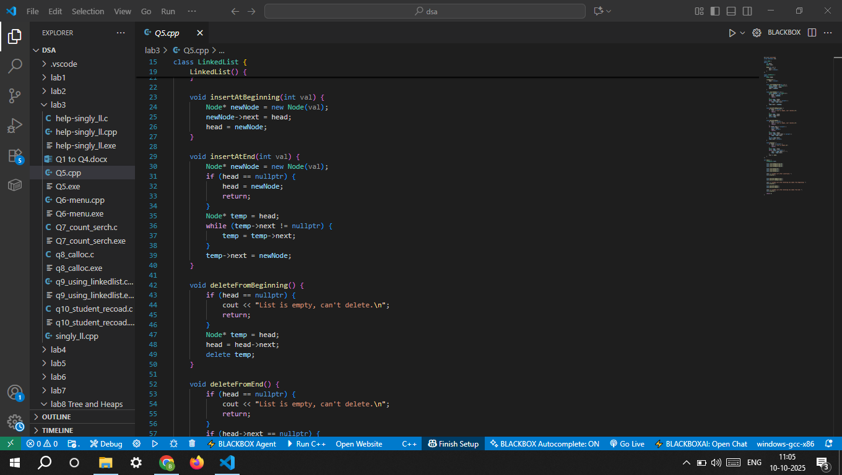
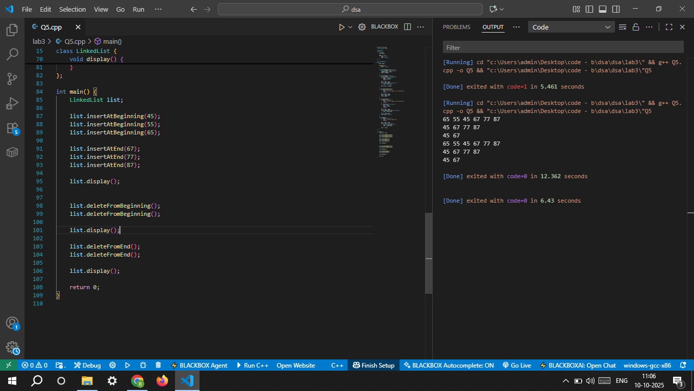

6. Modify the above program (C and C++ both) to make a Menu Driven application. And test the code by invoking the the function as per above given order.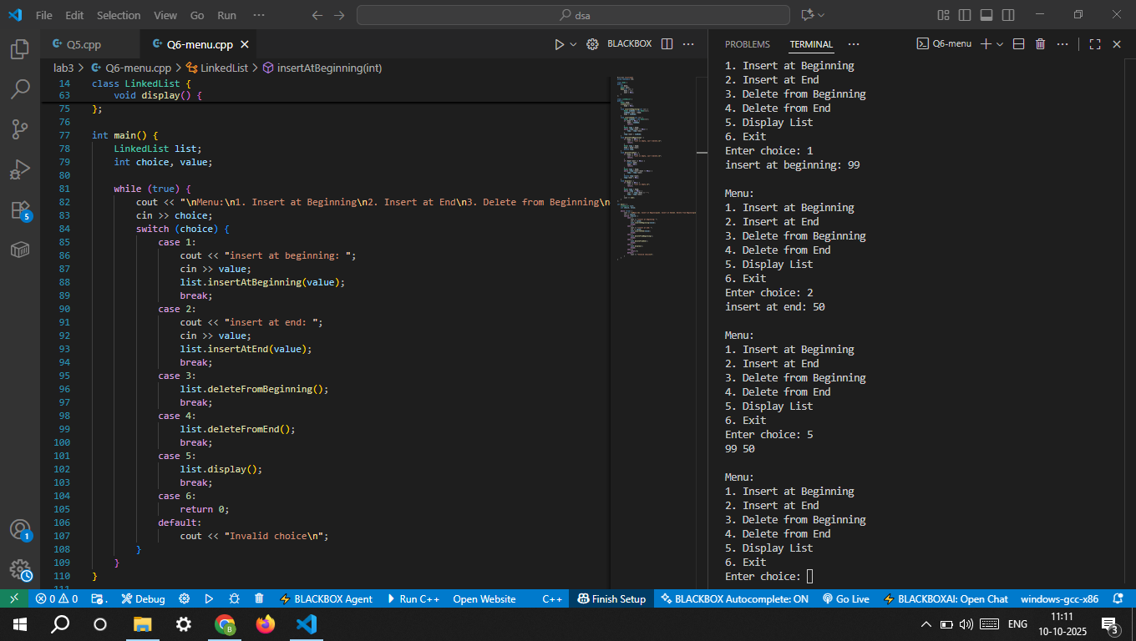

7. In the above C code, also add the code of Count the no. of nodes and search a node operation. 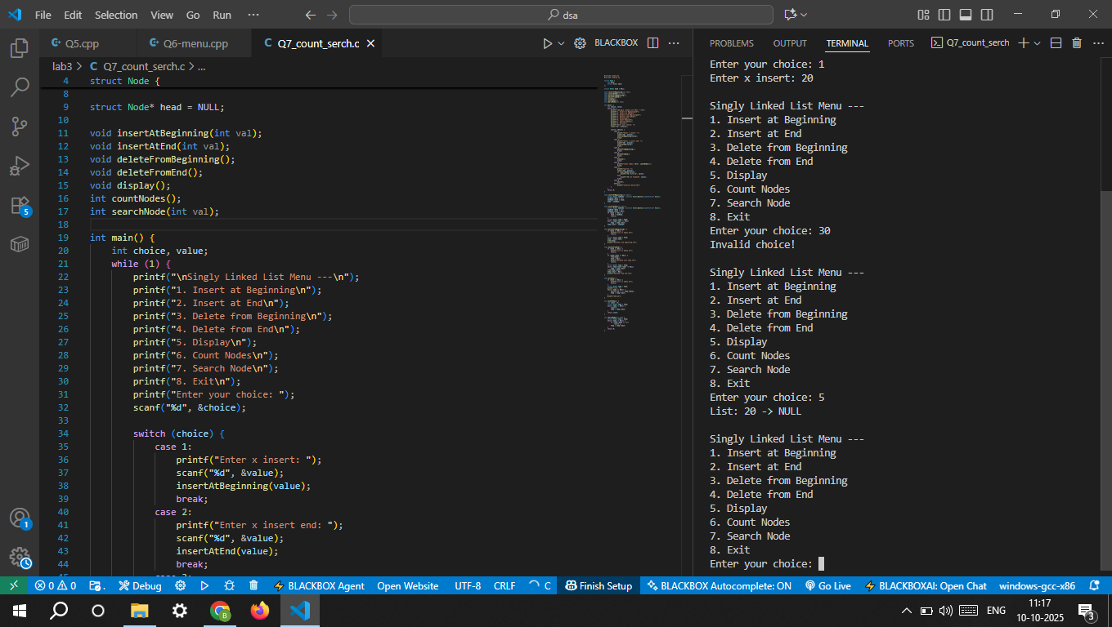

8. Modify the code of C implementation of Question 6 and use calloc() to allocate the memory for a node. 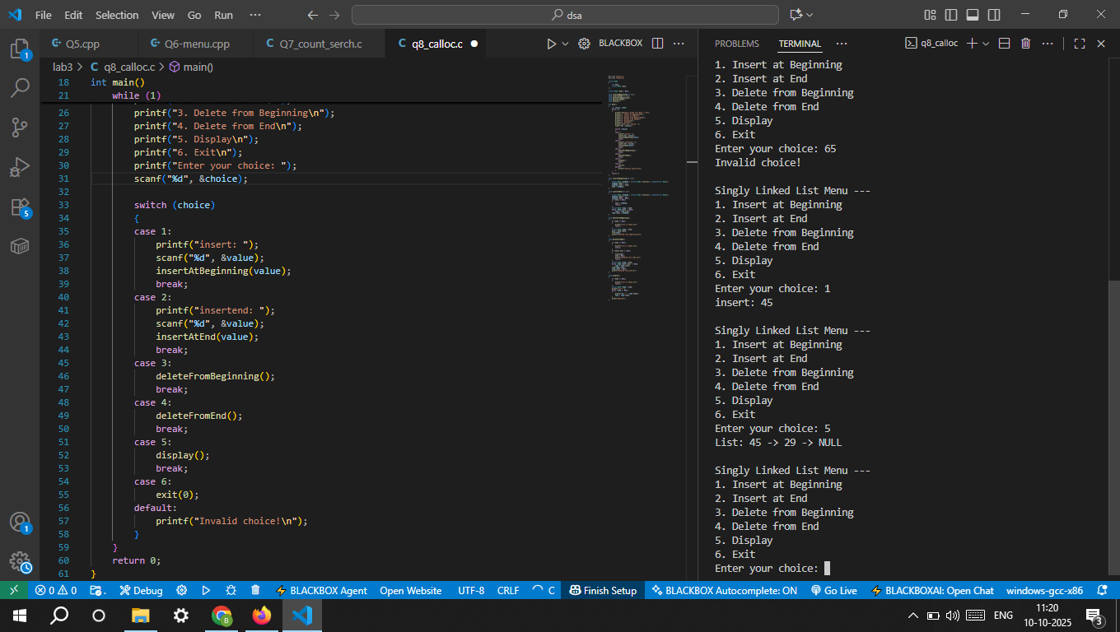

9. Write code for a function to create a Node of Linked List and call that function in the insert operations of Linekd List implementation of Question 6. 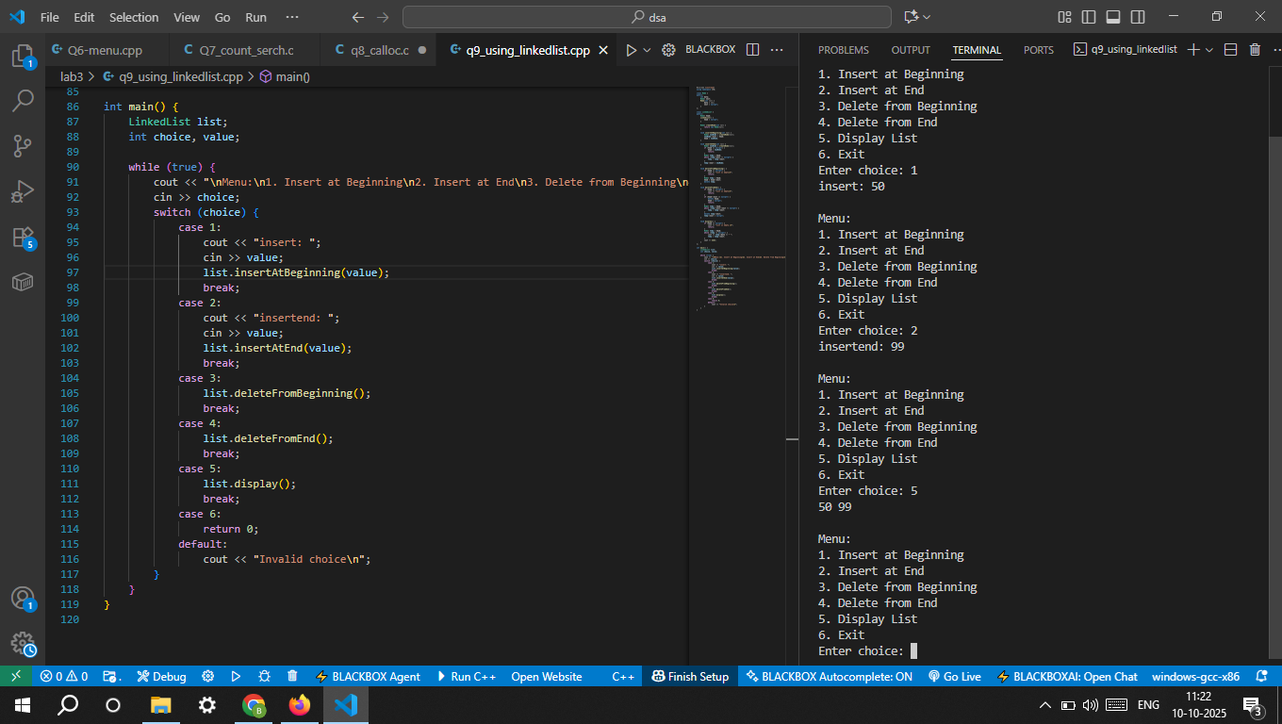

10. Create a menu-driven C program using a Singly Linked List to manage student records. Each node stores:
• Roll No. (treated as PRN) • Name • Phone Number • City • HSC Marks
The list supports:
• Insert at beginning • Insert at end • Delete from beginning • Delete from end • Display all records • Count records • Search by PRN (Roll No)
